# **Writing Task: Blog Post**

Based on your discussion and the list you created with your neighbor in task 20, you are going to write a blog post for your school's English blog.   
  
**Your task: Write a blog post in which you share your opinion on whether parents should OR shouldn't limit their children's screen time and computer/gaming use.  
  
In your blog post you should:**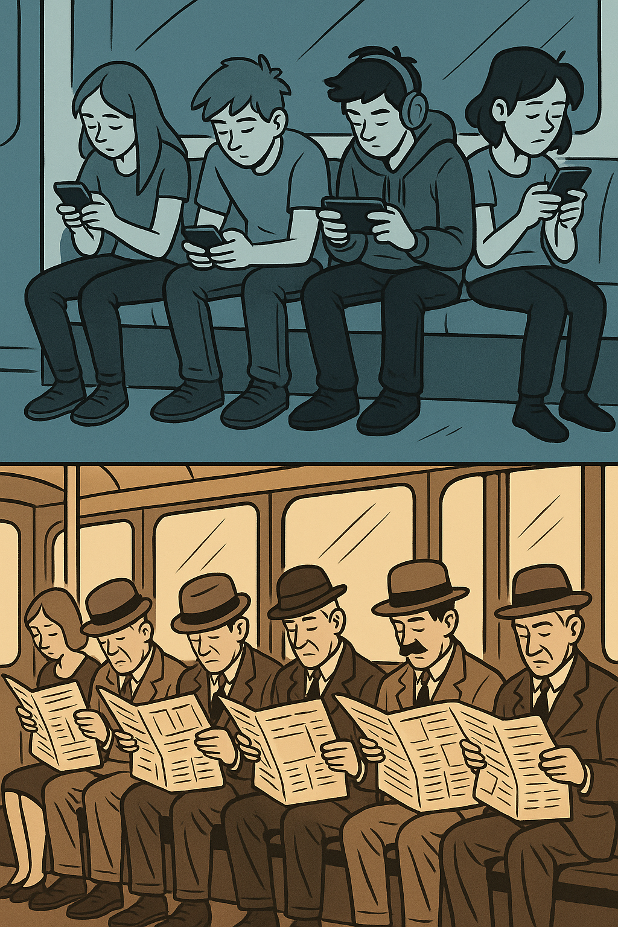

* give your blog post a catchy title
* involve your readership (use questions, address them directly)
* state your opinion clearly
* give reasons to support your view and include examples from your own experience
* address one counter-argument (what people who disagree might say) and respond to it
* end with a call to action (invite readers to comment, share their experiences, try something, etc.)

**Write around 200 words.**

# **Writing Task: Blog Post**

Based on your discussion and the list you created with your neighbor in task 20, you are going to write a blog post for your school's English blog.   
  
**Your task: Write a blog post in which you share your opinion on whether parents should OR shouldn't limit their children's screen time and computer/gaming use.  
  
In your blog post you should:**

* give your blog post a catchy title
* involve your readership (use questions, address them directly)
* state your opinion clearly
* give reasons to support your view and include examples from your own experience
* address one counter-argument (what people who disagree might say) and respond to it
* end with a call to action (invite readers to comment, share their experiences, try something, etc.)

**Write around 200 words.**